Lab 02

Nguyen Nam Tung 103181157

1. 4-bit adder

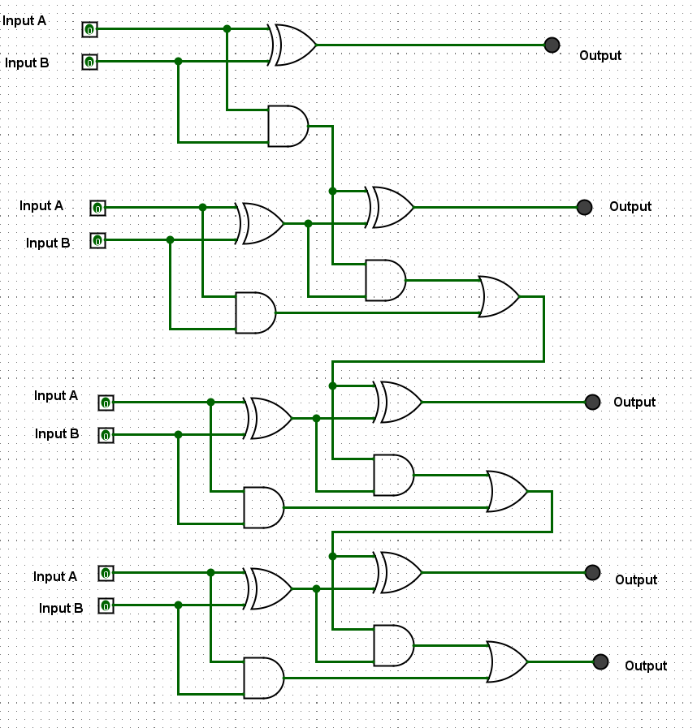

|  |  |  |
| --- | --- | --- |
| Input A | Input B | Output |
| 0101 | 0000 | 0101 |
| 0101 | 0001 | 0110 |
| 0101 | 0010 | 0111 |
| 0101 | 0011 | 1000 |
| 0101 | 0100 | 1001 |
| 0101 | 0101 | 1010 |
| 0101 | 0110 | 1011 |
| 0101 | 0111 | 1100 |
| 0101 | 1000 | 1101 |
| 0101 | 1001 | 1110 |
| 0101 | 1010 | 1111 |
| 0101 | 1011 | 0000 |
| 0101 | 1100 | 0001 |
| 0101 | 1101 | 0010 |
| 0101 | 1110 | 0011 |
| 0101 | 1111 | 0100 |

1. RS Flip Flop

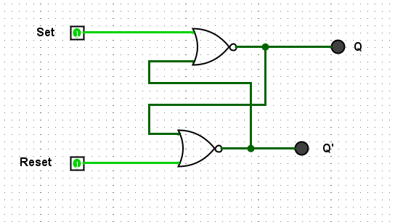

|  |  |  |  |
| --- | --- | --- | --- |
| Set | Reset | Q | Q’ |
| 1 | 0 | 0 | 1 |
| 1 | 1 | 0 | 0 |
| 0 | 1 | 1 | 0 |
| 1 | 1 | 0 | 0 |

**Describe in a sentence, the behaviour of the circuit when one of the inputs is 1 (but not both) and why this is useful for digital circuit design.**

When one of the inputs is 1, the output is unchanged. This is useful as the state of the circuits is stored.

**What do you notice about the two times you set both inputs to 1. Briefly explain what is happening here and why this is an issue for digital circuit design?**

When both of the inputs is 1, both of the outputs are 0, which is invalid as Q has to be opposite to Q’, Q and Q’ can’t be on and off at the same time. This is an issue as this is considered as an unstable state.

1. D Flip -Flop

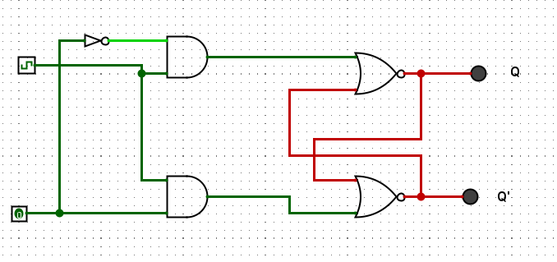

|  |  |  |  |
| --- | --- | --- | --- |
| Clock | Pin | Q | Q’ |
| 0 | 0 | 0 | 0 |
| 0 | 1 | 0 | 0 |
| 1 | 1 | 0 | 1 |
| 1 | 0 | 1 | 0 |

**Briefly explain the behaviour of a D Flip Flop and how it is useful for digital circuit design.**

* The D flip-flop has only one input, Q is updated to be the same as D when the clock goes active.
* The external D input (Data) internally generate both an R and an S input.
* These are complements so never get both being active at once, avoiding unstable state

**What is the role of the clock? How does it impact the changing of state of Q and Q’?**

The clock ensures the data flow is synchronized in a circuit

**Why is it generally preferred over the R-S Flip Flop?**

There is no illegal state and data can be synchronized

1. JK Flip Flop

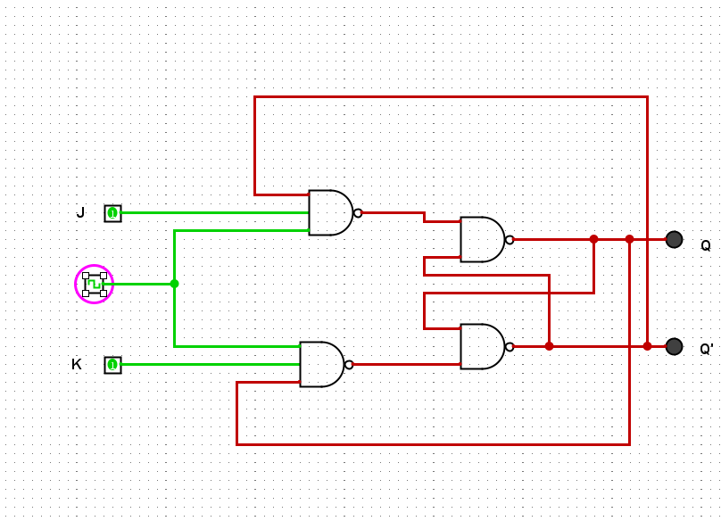

|  |  |  |  |
| --- | --- | --- | --- |
| J | K | Q (When clocked) | Q’ (When clocked) |
| 0 | 0 | 0 | 1 |
| 1 | 0 | 1 | 0 |
| 0 | 1 | 0 | 1 |
| 1 | 1 | 1 | 1 |

**How can a J-K Flip Flop be made to behave like a D Flip Flop?**

A NOT gate can be used

**How can a J-K Flop Flop be made to behave like a toggle (T Flip Flop)?**

Both inputs are 1, and is clocked